AMERICAN BANKER

'Economically invisible': A banker's push for better data on Native Americans
By Polo Rocha September 19, 2023, 9:00 p.m. EDT
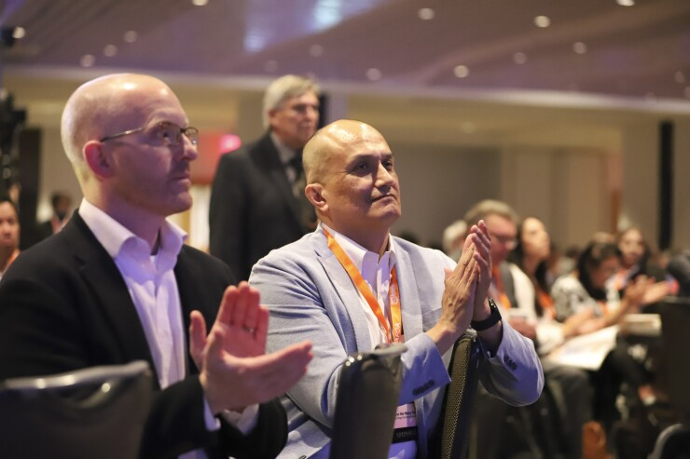
"If banks and financial institutions and asset managers don't see the opportunity here, if they don't understand how tribes are structured and the industries that they operate in, we're going to be economically invisible," says Dawson Her Many Horses (right), who grew up on the Rosebud reservation in South Dakota and is now a Wells Fargo managing director.
Native American Finance Officers Association

Dawson Her Many Horses, Wells Fargo's head of Native American banking, is on a mission to improve the availability of economic data across Indian Country.
The gaps in data are staggering, hampering the ability of tribes and the U.S. government to track economic outcomes and making it tougher for investors to drive capital into tribal communities.
Native leaders, the federal government and private sector leaders are all discussing ways to improve data collection and sharing, while recognizing tribes' sovereignty and ownership over their communities' data. Her Many Horses, a commercial banker who works with tribes, is playing a central role in thinking through those solutions.
"If banks and financial institutions and asset managers don't see the opportunity here, if they don't understand how tribes are structured and the industries that they operate in, we're going to be economically invisible," Her Many Horses said in an interview. "We're not going to get the capital that we need in our communities."
Her Many Horses, who grew up on the Rosebud reservation in South Dakota, has spent roughly two decades working with tribal governments and businesses. He's helped them issue bonds, get loans to expand their casino operations, diversify their revenue streams and manage their day-to-day cash.
His role in conversations about tribal data accelerated in 2018, when he joined Wells Fargo and asked for more resources to build the company's Native American banking business. Executives asked him to put together data outlining the business case.
"I thought it was a fair question, but I was also a little daunted by it," Her Many Horses said, pointing to the scant publicly available data and market analyses.
Her Many Horses and his team tracked down the available data and were ultimately able to paint a picture of Native communities. But the bigger lesson was about how difficult it was to do so — and the fact that it would be even tougher for investors with far less familiarity with tribal communities.
"How would they even go about it? They probably wouldn't, right? So that's where data comes in," Her Many Horses said.
A report last year by Wells Fargo and the Boston Consulting Group highlighted the size of the "data desert." It noted that the country lacks measurements of Native American gross domestic product, wealth and other critical metrics.
The report, released in the wake of a pandemic that hit Native communities particularly hard, focused on opportunities to make economies in Indian Country more resilient to downturns. But it also focused on the challenges those communities face, including a "fragmented" capital landscape, subpar broadband access, fewer bank branches and gaps in data.
While tribal governments can easily track data on their business operations, they aren't required to share that information, which the report said makes it hard for investors to identify opportunities. In 2020, the lack of publicly available data hampered federal officials' ability to target aid, according to the report.
The desire to keep financial information private is understandable, the report said, but a trusted entity could publish aggregate data while respecting tribes' confidentiality. One example is the annual revenue report from the National Indian Gaming Commission, which regulates tribally owned casinos.

'Open and honest dialogue'
In the months since the report's release, "open and honest dialogue" has taken place among tribal leaders, policymakers, researchers and private sector leaders, Her Many Horses said.
At a November 2022 discussion, participants raised past instances of the federal government and researchers misusing tribal data, according to a summary of the discussion. The Havasupai Indians, for example, won a settlement in 2010 after Arizona State University researchers used DNA samples from tribe members for research that went beyond their original purpose: explaining the prevalence of diabetes within their community.
But the discussion also found widespread agreement that, when it's done right, data-sharing can benefit tribal communities. It can help tribes qualify for more federal programs, track economic outcomes and outline the economic impact their communities have on each region of the country.
"What had begun as a tentative conversation about leveraging tribal data to attract private investment quickly evolved into a deeper, richer and more heartfelt discussion about the ways tribal data can be weaponized by non-Indian stakeholders — or leveraged by tribal citizens to strengthen tribal operations and showcase tribal economic power," reads a summary of the meeting, which was convened by Wells Fargo and the Aspen Institute Financial Security Program.
Similar work is taking place at the Federal Reserve Bank of Minneapolis' Center for Indian Country Development, which analyzes tribal economic data and researches the topic. Native people have analyzed data on the natural world, health and trade "since time immemorial," Casey Lozar, the center's director, wrote this year.
Some tribal data now lives on complex spreadsheets; other data is in stories passed on over generations. But data collection has expanded both within tribes and outside of them — shedding more light on Native businesses, investment opportunities, the availability of credit, housing and other key issues.
"High-quality intertribal data would complement the lived experience of Indian Country and allow us to pen our own accurate economic narrative," wrote Lozar, an enrolled member of the Confederated Salish and Kootenai Tribes.

A 'fairly unique' position
Her Many Horses will continue playing a role in those conversations both at Wells Fargo and at the Aspen Institute, a global think tank where he was recently named a finance leader fellow. Wells recently promoted him to a managing director, which the $1.9 trillion-asset bank said made him one of the first enrolled tribal members in that role at a major U.S. bank.
Robert Maxim, a senior research associate at the Brookings Institution and a citizen of the Mashpee Wampanoag Tribe, credited Wells Fargo for elevating Her Many Horses to a position that he said appears to be "fairly unique" among big banks.
"It is still relatively rare for banks to be thinking about Native communities and Indigenous communities," Maxim said, adding that having Native people in key roles can help lenders understand the nuances of working in those communities.
"The fact that he's in the position he's in, I think, really matters," added Maxim, whose research has focused on the need for changes to the U.S. census and on labor trend data that shows that Native Americans' recovery from COVID-19 is far from complete.
Her Many Horses didn't intend to work in banking early on. As a child, he said he was often told to "get a law degree so that you can become a better advocate for tribal communities."
At Columbia University, he majored in political science. Then, in order to bolster his law school application, he got an internship in Merrill Lynch's office of the general counsel.
The internship translated into a permanent job at Merrill Lynch, where he led efforts to develop a companywide Native American market strategy. He'd soon focus specifically on investment banking, helping underwrite Native American casino-related bond issuances.
"There weren't any other Native Americans in investment banking" at the time, just before the 2008 financial crisis hit, Her Many Horses said.
He recalled one pitch meeting where higher-ups at Merrill presented to an East Coast tribe. Her Many Horses had put together the meeting presentation, but he didn't expect to have to speak up.
"The treasurer of the tribe who we're presenting to just looked at me and said, 'Hey Dawson, what do you think about this deal?'" he recounted.
Her Many Horses got an M.B.A. from Dartmouth and soon returned to Merrill Lynch — which had by then been folded into Bank of America in a crisis-era deal. He was a senior relationship manager on the casino team, where he continued his prior work and gained more perspective on tribal economic development.
Wells Fargo hired him in 2018 and promoted him to head of Native American banking in 2021. According to his LinkedIn page, the unit's revenues have risen considerably in recent years despite two controversies that hurt Wells' reputation in the Native American market: the bank's sales practices scandal and its financing of a controversial oil pipeline.
The bank was facing significant pushback from shareholders, activists and civic leaders over the Dakota Access Pipeline project, while it was also grappling with the fallout of revelations that its employees had opened millions of unauthorized accounts for consumers.
Dawson said he joined the bank because it's "important that tribes have banking options." Most large banks only work with tribal casinos, but Wells Fargo also works with clients such as tribal governments, Alaska Native regional corporations and Alaska Native villages.
"You can't say you're committed to a community if you only do business with a small segment of it," Her Many Horses said. "I wanted to build a business that our clients and Wells Fargo employees could be proud of."

